# Arduino Uno R3

Arduino Uno R3 is an open-source microcontroller board based on the ATmega328P. It is the most popular version of Arduino, ideal for beginners and prototyping.

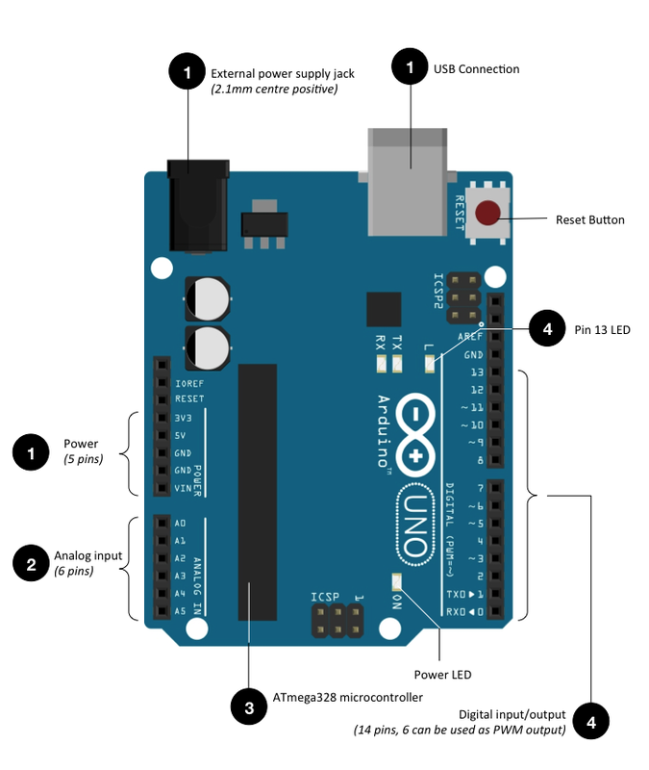

Fig: Arduino Uno R3 Pinout

**Pin Layout:**

1. Power

* the board can be powered via the USB connection or with an external power supply (range 7V to 12V)
* Vin - supply voltage through this pin or via the power supply jack when using an external power supply
* GND: ground pins
* 5V: regulated power supply used to power the components on board
* 3v3: a 3.3V supply voltage
* RESET: bring this line LOW to reset the micro-controller. Typically used to add a reset button to shield which block the one on the board (reset button)

2. Analog Input

* each input provides 10-bits of resolution (ie. 1024 different values). By default they measure from GND to 5V, mapping values from 0 to 1023 respectively

3. Memory

* 32KB of flash memory for storing code (sketch of your program)

4. Digital Input/Output

* each pin can be an input or output, using *pinMode( )*, *digitalWrite( )*, and *digitalRead( )* functions
* each pin operates at 5V and can provide or receive a maximum of 40mA
* PWM: 3, 5, 6, 9, 10, 11 - provide a PWM output with the *analogWrite( )* function
* LED13: built-in LED connected to pin 13. When this pin is HIGH, the LED is on, when this pin is LOW, it is off

**Key Features:**  
- 14 Digital I/O pins (6 PWM)  
- 6 Analog inputs  
- 16 MHz clock speed  
- USB-B port for programming  
- Power jack (7-12V)  
- ICSP header and reset button

**Working Principle:**  
Connect to PC via USB. Write code using Arduino IDE (C/C++). Upload sketch to flash memory. Interact with the real world using sensors, motors, LEDs, etc.

**Variants**:  
- Arduino Mega  
- Nano/Mini  
- Leonardo  
- Due

**Applications**:  
- Robotics  
- Home automation  
- IoT systems  
- Wearable devices  
- Educational kits

**Advantages**:  
- Easy to program and use  
- Huge online community and libraries  
- Plug-and-play hardware  
- Cross-platform support

**Disadvantages**:  
- Limited memory and speed  
- Not suitable for commercial embedded systems  
- Lower performance than Raspberry Pi